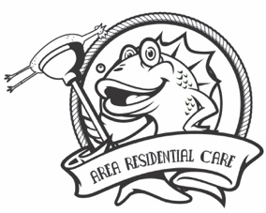
2023 Corporate and Community Games Registration Form
June 9, 2023
Contact Information
Name:________________________________________________________________________
Business:_____________________________________________________________________
Address:________________________________City_________________State____Zip_______
E-mail________________________________________________________________________
Phone Number:_______________________________________________________________
Team Name #1________________________________________________________________
Captain of Team #1_____________________________________________________________
E-mail of Team Captain__________________________________________________________
Team Name #2 (included with Major, Platinum & Premier sponsors or for an additional $200 team registration)
____________________________________________________________________________
Captain of Team #2____________________________________________________________
E-mail of Team Captain__________________________________________________________
Sponsorship Level
- Premier Sponsor $2,800
- Major Sponsor $1,750
- Platinum Sponsor $1,250
- Gold Sponsor $650
- Silver Sponsor $400
- General Registration (non-sponsor) $300
Please return with check to Area Residential Care Attn: Marketing 3355 Kennedy Circle Dubuque, IA 52002 or register and pay online at www.arearesidentialcare.org. Sponsorships are due by May 1, 2023 to receive full sponsorship benefits and be included in marketing materials.

